-Project Name-

Blue Print Document

Document no: 001

Document Control

Date | Name | Role | Signature
BSA Manager
IT Dept Section Concern
Developer Manager
IT Dept Section Concern
BSA
IT Dept members
System Delivery
IT Dept members

CONTENTS

1. Introduction 5
1.1 Purpose of Document 5
1.2 Scope 5
1.3 Definitions, Acronyms, and Abbreviations 5
1.4 References 5
2. Configuration 5
2.1 System Configuration 5
2.2 Network Configuration 5
3. Process Specification 6
3.1 Global business Process Flow 6
3.2 System Relationship Diagram 6
3.2.1 Entity Relation Diagram 7
3.2.2 Functional list 7
3.2.3 Screen Design Input, Process, and Output 7
3.2.4 Report Design 7
3.2.5 API/Batch Design 7

- Introduction
  - Purpose of Document
  - Scope
  - Definitions, Acronyms, and Abbreviations
  - References

- Configuration

  - System Configuration
This RFWMS-DC Application will provide a configuration form that will be used by user to manage the interface application. The configurations are:
- A configuration file (text file) that contains information of server name, database name, database user login, and authentication mode.
- At least .NET Framework 2.0 should be installed on each workstation to run this application.
  - Network Configuration

- Process Specification

  - Global business Process Flow
----

  - System Relationship Diagram
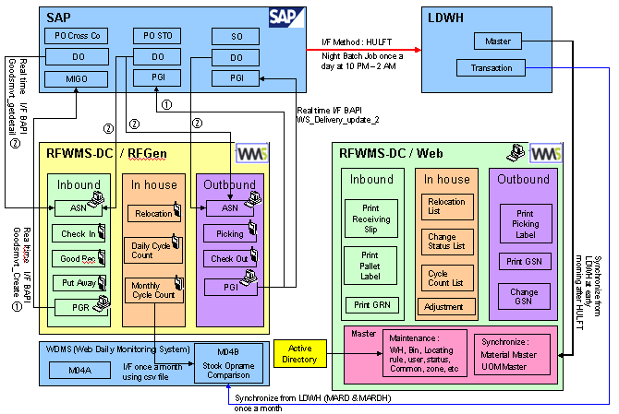

    - Entity Relation Diagram
    - Functional list

    - Screen Design Input, Process, and Output

    - Report Design Input, Process, and Output

    - API/Batch Design

-End Document-

